Table 12

Baseline and Method-U Models Standardized Factor Loadings for All Leadership Indicators

|  |  |  |  |  |  |
| --- | --- | --- | --- | --- | --- |
| Construct Indicator | Baseline model estimates | Method model substantive estimates | Substantive estimates squared | Liking estimates (MFLs) | Liking estimates squared |
| Transformational Leadership | | | | | |
| Intellectual Stimulation 1 | 0.754*** | 0.739*** | 0.546 | 0.258*** | 0.067 |
| Intellectual Stimulation 2 | 0.725*** | 0.596*** | 0.355 | 0.412*** | 0.170 |
| Intellectual Stimulation 3 | 0.822*** | 0.715*** | 0.511 | 0.429*** | 0.184 |
| Intellectual Stimulation 4 | 0.882*** | 0.722*** | 0.521 | 0.502*** | 0.252 |
| Idealized Behaviors 1 | 0.734*** | 0.713*** | 0.508 | 0.300*** | 0.090 |
| Idealized Behaviors 2 | 0.823*** | 0.787*** | 0.619 | 0.394*** | 0.155 |
| Idealized Behaviors 3 | 0.806*** | 0.564*** | 0.318 | 0.545*** | 0.297 |
| Idealized Behaviors 4 | 0.815*** | 0.727*** | 0.529 | 0.428*** | 0.183 |
| Inspirational Motivation 1 | 0.839*** | 0.748*** | 0.559 | 0.463*** | 0.214 |
| Inspirational Motivation 2 | 0.790*** | 0.725*** | 0.526 | 0.415*** | 0.172 |
| Inspirational Motivation 3 | 0.875*** | 0.747*** | 0.558 | 0.488*** | 0.238 |
| Inspirational Motivation 4 | 0.812*** | 0.481*** | 0.231 | 0.625*** | 0.391 |
| Idealized Attributes 1 | 0.838*** | 0.711*** | 0.506 | 0.554*** | 0.307 |
| Idealized Attributes 2 | 0.818*** | 0.587*** | 0.344 | 0.557*** | 0.310 |
| Idealized Attributes 3 | 0.896*** | 0.533*** | 0.284 | 0.711*** | 0.506 |
| Idealized Attributes 4 | 0.599*** | 0.599*** | 0.359 | 0.327*** | 0.107 |
| Individual Consideration 1 | 0.789*** | 0.698*** | 0.487 | 0.478*** | 0.229 |
| Individual Consideration 2 | 0.760*** | 0.285** | 0.081 | 0.666*** | 0.444 |
| Individual Consideration 3 | 0.451*** | 0.297** | 0.088 | 0.319*** | 0.102 |
| Individual Consideration 4 | 0.876*** | 0.657*** | 0.432 | 0.587*** | 0.344 |
| Liking 1 | 0.732 a *** |  |  |  |  |
| Liking 2 | 0.928 a *** |  |  |  |  |
| Liking 3 | 0.887 a *** |  |  |  |  |
| Liking 4 | 0.932 a *** |  |  |  |  |
| LMX | | | | | |
| Professional Respect 1 | 0.89*** | 0.81*** | 0.65 | 0.44*** | 0.19 |
| Professional Respect 2 | 0.92*** | 0.67*** | 0.45 | 0.62*** | 0.38 |
| Professional Respect 3 | 0.92*** | 0.72*** | 0.52 | 0.57*** | 0.32 |
| Affect 1 | 0.86*** | 0.92*** | 0.84 | 0.79*** | 0.63 |
| Affect 2 | 0.89*** | 0.06** | 0.003 | 0.85*** | 0.72 |
| Affect 3 | 0.84*** | 0.09** | 0.009 | 0.78*** | 0.61 |
| Contribution 1 | 0.88*** | 0.76*** | 0.57 | 0.49*** | 0.24 |
| Contribution 2 | 0.71*** | 0.65*** | 0.42 | 0.40*** | 0.16 |
| Contribution 3 | 0.91*** | 0.75*** | 0.57 | 0.53*** | 0.28 |
| Loyalty 1 | 0.90*** | 1.02*** | 1.03 | 0.68*** | 0.46 |
| Loyalty 2 | 0.88*** | 0.18*** | 0.03 | 0.75*** | 0.56 |
| Loyalty 3 | 0.74*** | 0.18*** | 0.03 | 0.56*** | 0.31 |
| Liking 1 | 0.74 a *** |  |  |  |  |
| Liking 2 | 0.94 a *** |  |  |  |  |
| Liking 3 | 0.88 a *** |  |  |  |  |
| Liking 4 | 0.96 a *** |  |  |  |  |
| Ethical Leadership | | | | | |
| Ethical Leadership 1 | 0.74*** | 0.15* | 0.02 | 0.73*** | 0.53 |
| Ethical Leadership 2 | 0.46*** | 0.28*** | 0.08 | 0.40*** | 0.16 |
| Ethical Leadership 3 | 0.68*** | 0.23*** | 0.05 | 0.63*** | 0.40 |
| Ethical Leadership 4 | 0.84*** | 0.29*** | 0.09 | 0.78*** | 0.61 |
| Ethical Leadership 5 | 0.81*** | 0.32*** | 0.10 | 0.74*** | 0.54 |
| Ethical Leadership 6 | 0.81*** | 0.16*** | 0.03 | 0.80*** | 0.65 |
| Ethical Leadership 7 | 0.61*** | 0.34*** | 0.11 | 0.53*** | 0.29 |
| Ethical Leadership 8 | 0.82*** | 0.42*** | 0.18 | 0.72*** | 0.52 |
| Ethical Leadership 9 | 0.78*** | 0.44*** | 0.19 | 0.68*** | 0.46 |
| Ethical Leadership 10 | 0.73*** | 0.37*** | 0.14 | 0.64*** | 0.41 |
| Liking 1 | 0.87 a *** |  |  |  |  |
| Liking 2 | 0.96 a *** |  |  |  |  |
| Liking 3 | 0.86 a *** |  |  |  |  |
| Liking 4 | 0.95 a *** |  |  |  |  |
| Toxic Leadership | | | | | |
| Self-Promotion 1 | 0.736*** | 0.685*** | 0.469 | -0.401*** | 0.161 |
| Self-Promotion 2 | 0.767*** | 0.504*** | 0.254 | -0.553*** | 0.306 |
| Self-Promotion 3 | 0.805*** | 0.617*** | 0.381 | -0.518*** | 0.268 |
| Self-Promotion 4 | 0.800*** | 0.594*** | 0.353 | -0.529*** | 0.280 |
| Self-Promotion 5 | 0.865*** | 0.575*** | 0.331 | -0.628*** | 0.394 |
| Abusive Supervision 1 | 0.825*** | 0.745*** | 0.555 | -0.446*** | 0.199 |
| Abusive Supervision 2 | 0.661*** | 0.412*** | 0.170 | -0.476*** | 0.227 |
| Abusive Supervision 3 | 0.721*** | 0.384*** | 0.147 | -0.589*** | 0.347 |
| Abusive Supervision 4 | 0.863*** | 0.743*** | 0.552 | -0.466*** | 0.217 |
| Abusive Supervision 5 | 0.865*** | 0.795*** | 0.632 | -0.427*** | 0.182 |
| Abusive Supervision 6 | 0.777*** | 0.592*** | 0.350 | -0.492*** | 0.242 |
| Abusive Supervision 7 | 0.797*** | 0.709*** | 0.503 | -0.419*** | 0.176 |
| Unpredictability 1 | 0.799*** | 0.767*** | 0.588 | -0.331*** | 0.110 |
| Unpredictability 2 | 0.818*** | 0.659*** | 0.434 | -0.487*** | 0.237 |
| Unpredictability 3 | 0.833*** | 0.711*** | 0.506 | -0.460*** | 0.212 |
| Unpredictability 4 | 0.802*** | 0.735*** | 0.540 | -0.382*** | 0.146 |
| Unpredictability 5 | 0.702*** | 0.483*** | 0.233 | -0.486*** | 0.236 |
| Unpredictability 6 | 0.792*** | 0.584*** | 0.341 | -0.521*** | 0.271 |
| Unpredictability 7 | 0.695*** | 0.655*** | 0.429 | -0.324*** | 0.105 |
| Narcissism 1 | 0.799*** | 0.684*** | 0.468 | -0.550*** | 0.303 |
| Narcissism 2 | 0.787*** | 0.688*** | 0.473 | -0.438*** | 0.192 |
| Narcissism 3 | 0.836*** | 0.656*** | 0.430 | -0.523*** | 0.274 |
| Narcissism 4 | 0.747*** | 0.711*** | 0.506 | -0.369*** | 0.136 |
| Narcissism 5 | 0.693*** | 0.641*** | 0.411 | -0.371*** | 0.138 |
| Authoritarian Leadership 1 | 0.707*** | 0.703*** | 0.494 | -0.270*** | 0.073 |
| Authoritarian Leadership 2 | 0.782*** | 0.576*** | 0.332 | -0.509*** | 0.259 |
| Authoritarian Leadership 3 | 0.761*** | 0.582*** | 0.339 | -0.481*** | 0.231 |
| Authoritarian Leadership 4 | 0.820*** | 0.498*** | 0.248 | -0.621*** | 0.386 |
| Authoritarian Leadership 5 | 0.758*** | 0.550*** | 0.303 | -0.503*** | 0.253 |
| Authoritarian Leadership 6 | 0.660*** | 0.498*** | 0.248 | -0.426*** | 0.181 |
| Liking 1 | 0.675 a *** |  |  |  |  |
| Liking 2 | 0.956 a *** |  |  |  |  |
| Liking 3 | 0.907 a *** |  |  |  |  |
| Liking 4 | 0.921 a *** |  |  |  |  |
| Abusive Supervision | | | | | |
| Abusive Leadership 1 | 0.738*** | 0.609*** | 0.371 | -0.453*** | 0.205 |
| Abusive Leadership 2 | 0.801*** | 0.687*** | 0.472 | -0.469*** | 0.220 |
| Abusive Leadership 3 | 0.744*** | 0.555*** | 0.308 | -0.506*** | 0.256 |
| Abusive Leadership 4 | 0.834*** | 0.641*** | 0.411 | -0.553*** | 0.306 |
| Abusive Leadership 5 | 0.719*** | 0.524*** | 0.275 | -0.483*** | 0.233 |
| Abusive Leadership 6 | 0.737*** | 0.530*** | 0.281 | -0.500*** | 0.250 |
| Abusive Leadership 7 | 0.614*** | 0.239*** | 0.057 | -0.623*** | 0.388 |
| Abusive Leadership 8 | 0.737*** | 0.421*** | 0.177 | -0.608*** | 0.370 |
| Abusive Leadership 9 | 0.721*** | 0.359*** | 0.129 | -0.649*** | 0.421 |
| Abusive Leadership 10 | 0.717*** | 0.482*** | 0.232 | -0.519*** | 0.269 |
| Abusive Leadership 11 | 0.782*** | 0.523*** | 0.274 | -0.571*** | 0.326 |
| Abusive Leadership 12 | 0.849*** | 0.540*** | 0.292 | -0.657*** | 0.432 |
| Abusive Leadership 13 | 0.653*** | 0.567*** | 0.321 | -0.370*** | 0.137 |
| Abusive Leadership 14 | 0.752*** | 0.630*** | 0.397 | -0.444*** | 0.197 |
| Abusive Leadership 15 | 0.798*** | 0.481*** | 0.231 | -0.628*** | 0.394 |
| Liking 1 | 0.886 a *** |  |  |  |  |
| Liking 2 | 0.954 a *** |  |  |  |  |
| Liking 3 | 0.908 a *** |  |  |  |  |
| Liking 4 | 0.948 a *** |  |  |  |  |

*p < .05, ***p < .001. Factor loadings taken from the CFA Model and held constant through the model comparison are marked with the letter "a". Factor loadings are standardized. Substantive estimates are TL items loadings on their substantive factors in the Method-U model. Liking method model estimates are TL item loadings on liking in the Method-U model. The squared standardized factor loadings are used to determine the percentage of variance in each leadership indicator due to Liking or due to substantive factors.

Figure 1

Baseline Model for LMX

This is an example of what the Baseline model looks like for a multi-factor leadership construct. The model includes the leadership construct’s (i.e. LMX) latent variables and their measured indicators. The model includes direct paths from the latent variables to their indicators (i.e., substantive factor loadings. Latent Variables are allowed to freely correlate, while the liking factor remains orthogonal to the leadership factors.

Figure 2

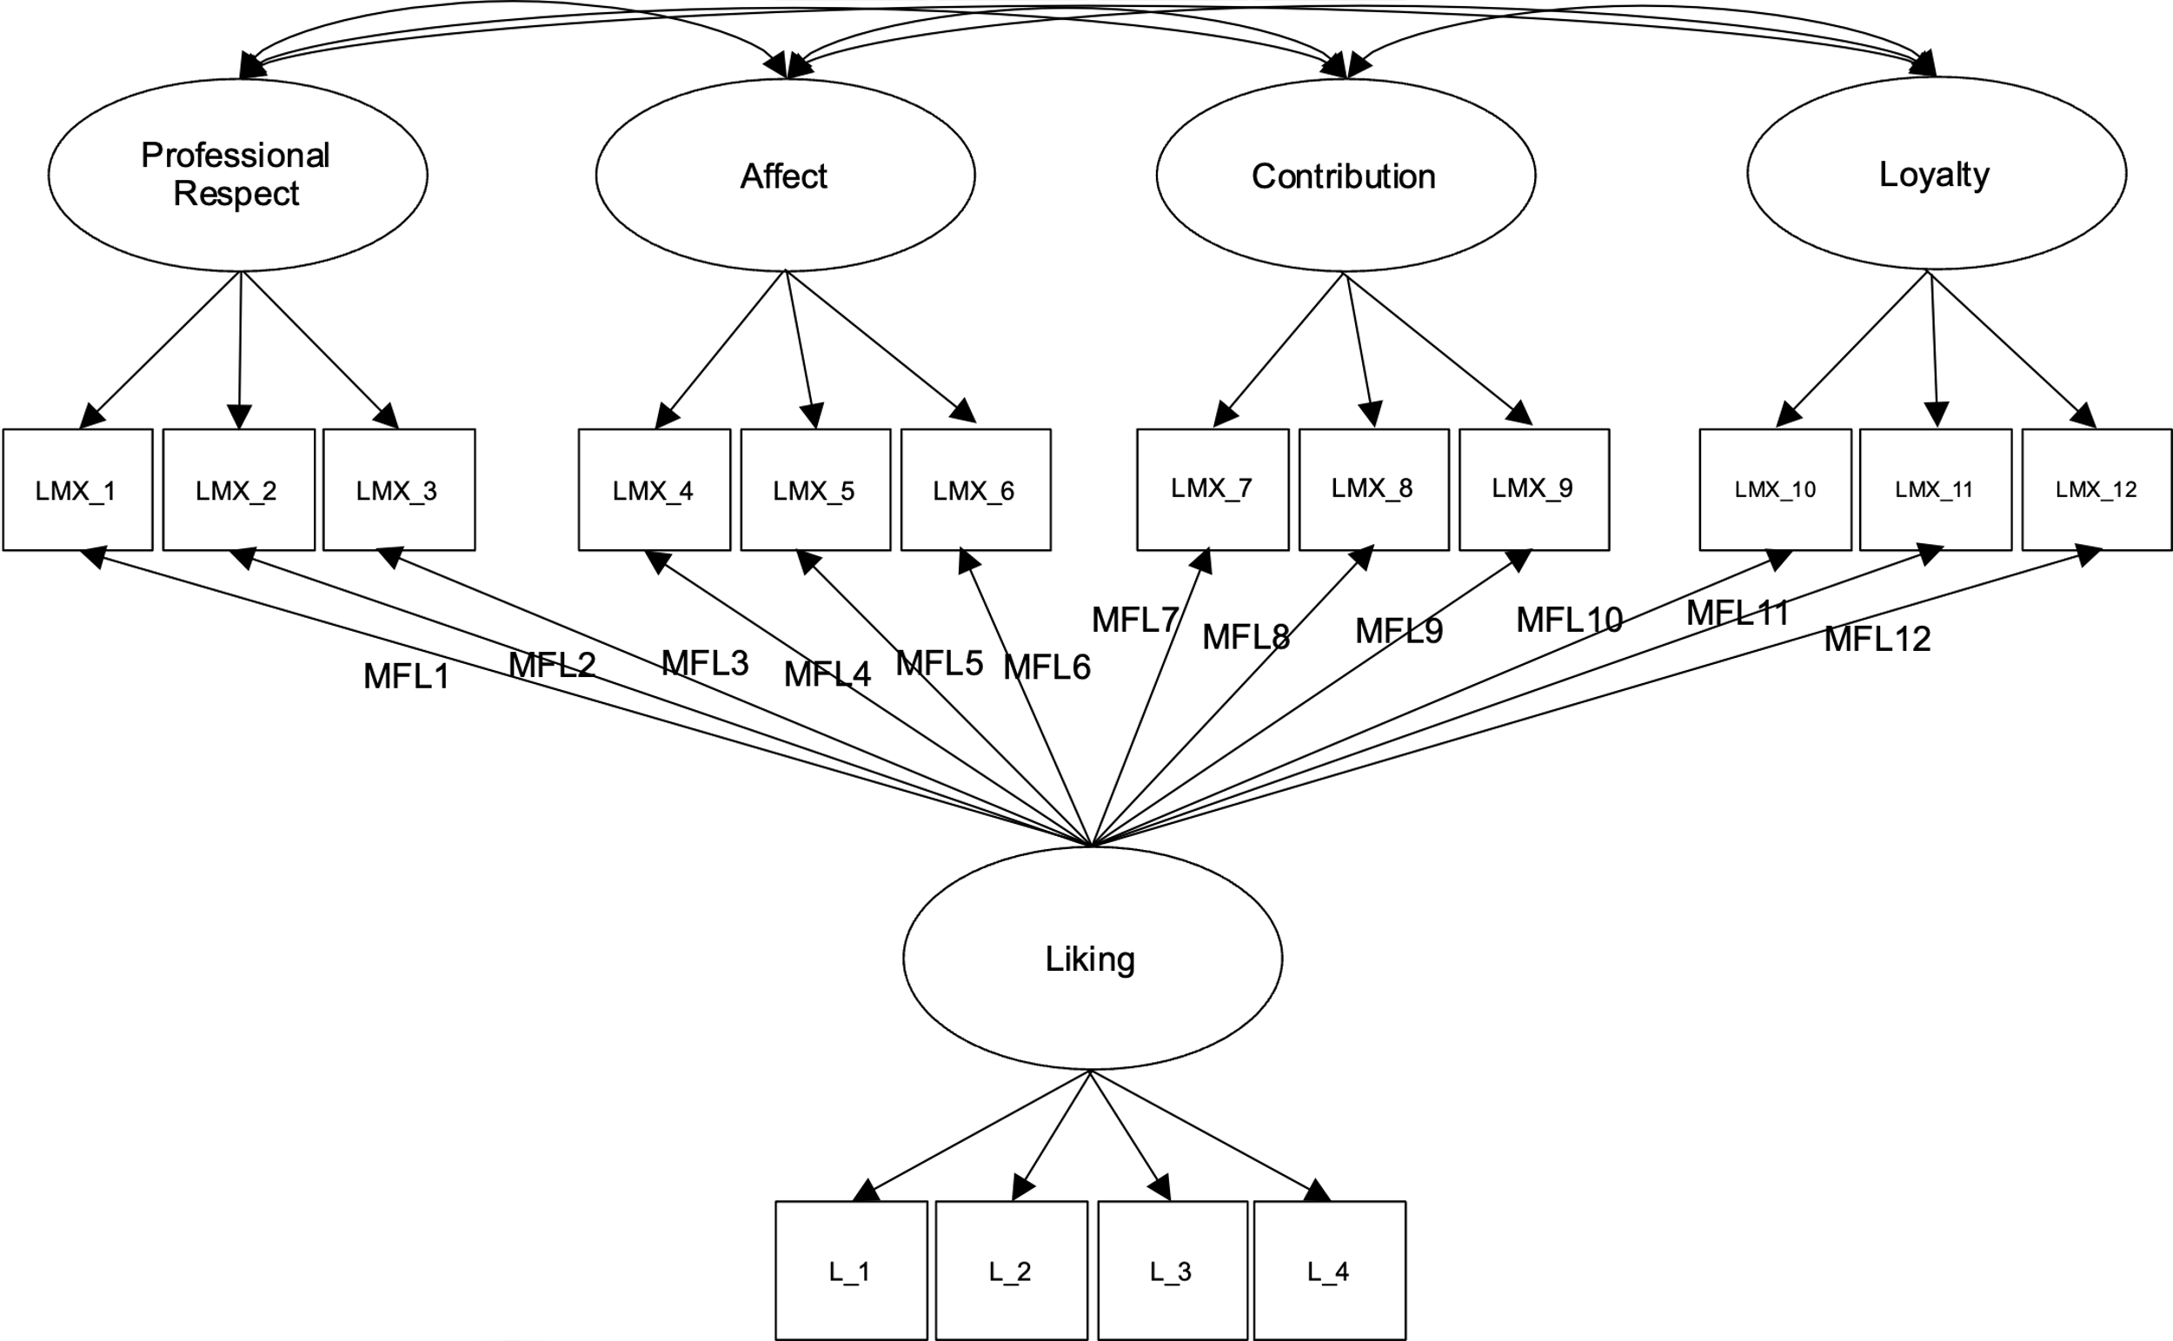Method Model for LMX

This is an example of what the Method-U model looks like for a multi-factor leadership construct. The model includes the leadership construct’s (i.e. LMX) latent variables and their measured indicators. The model includes direct paths from the latent variables to their indicators (i.e., substantive factor loadings), and direct paths from the Liking factor to the leadership indicators (i.e., Method Factor Loadings (MFLs)). Latent Variables are allowed to freely correlate, while the liking factor remains uncorrelated.

Figure 3

Baseline Model for Ethical Leadership

This is an example of what the Method-U model looks like for a unidimensional leadership construct. The model includes the leadership construct (i.e. Ethical Leadership) and its measured indicators. The model includes direct paths from the leadership factor to its indicators (i.e., substantive factor loadings). The liking factor remains orthogonal to the leadership factor.

Figure 4

Method Model for Ethical Leadership

This is an example of what the Method-U model looks like for a unidimensional leadership construct. The model includes the leadership construct (i.e. Ethical Leadership) and its measured indicators. The model includes direct paths from the leadership factor to its indicators (i.e., substantive factor loadings), and direct paths from the Liking factor to the leadership indicators (i.e., Method Factor Loadings (MFLs)).

Figure 5

Structural Baseline Model for LMX

This model specified direct paths from LMX to the organizational outcomes with liking included but uncorrelated with other constructs. Dotted lines in the path diagram represent the covariances/correlations that were constrained to zero in the model.

Figure 6

Structural Method Model for LMX

This model adds direct paths from the liking factor to all substantive indicators (both leadership and outcome measures).

Figure 7

Structural Baseline Model for Ethical Leadership

This model specified direct paths from Ethical Leadership to the organizational outcomes with Liking included but uncorrelated with other constructs. Dotted lines in the path diagram represent the covariances/correlations that were constrained to zero in the model.

Figure 8

Structural Method Model for Ethical Leadership

This model adds direct paths from the liking factor to all substantive indicators (both leadership and outcome measures).